12th IEEE International Women in Engineering (WIE) Conference on Electrical and Computer Engineering 2026 (IEEE WIECON-ECE 2026)

Recalibration Data Requirements for Battery Failure Prediction Under Operational Distribution Shift

line 1: 1st Given Name Surname  line 2: dept. name of organization  line 3: name of organization  line 4: City, Country  line 5: email address or ORCID | line 1: 2nd Given Name Surname  line 2: dept. name of organization  line 3: name of organization  line 4: City, Country  line 5: email address or ORCID | line 1: 3rd Given Name Surname  line 2: dept. name of organization  line 3: name of organization  line 4: City, Country  line 5: email address or ORCID
line 1: 4th Given Name Surname  line 2: dept. name of organization  line 3: name of organization  line 4: City, Country  line 5: email address or ORCID | line 1: 5th Given Name Surname  line 2: dept. name of organization  line 3: name of organization  line 4: City, Country  line 5: email address or ORCID

Abstract—Probabilistic battery failure prediction models are trained on clean laboratory cycling data and deployed under operating conditions that differ from the training distribution. This paper asks how much field data is needed to restore the calibration of a frozen multihorizon hazard model after such a shift. Partial discharge, temperature noise, and rest irregularity are applied at four severity levels with five seeds each. Expected calibration error (ECE) rises from 0.23–0.41 on clean held-out data to 0.31–0.51 under perturbation and saturates at the mildest severity. Refitting the isotonic map on a field sample cuts perturbed ECE monotonically, from a mean of 0.221 at a 5% sample to 0.121 at 20%, with only marginal gains beyond. The 20% requirement holds at every horizon. Domain-randomized retraining does not beat this lightweight recalibration at any horizon except H = 10. The practical recommendation is to keep the base model, collect about one-fifth of a field window, and refit the calibrator.
Keywords—battery energy storage, calibration, distribution shift, hazard learning, isotonic regression, recalibration.
- Introduction

Battery energy storage systems are dispatched for grid services on a routine basis. Operators need more than the energy a battery can deliver. They need a trustworthy probability that the battery completes a committed service within a predefined horizon, because dispatch decisions are gated by probability thresholds. A multihorizon hazard model predicts, for each cycle, the probability of failure within 10 to 50 cycles and uses isotonic regression to turn raw scores into calibrated probabilities. When the probabilities drift, threshold-gated dispatch makes unsafe or uneconomical decisions.
Laboratory-trained models meet three systematic shifts in the field: partial cycles at varying depth of discharge (DoD), irregular rest intervals, and fluctuating thermal conditions.
The prognostics literature has mapped state-of-health (SOH) estimation and remaining-useful-life (RUL) prediction in detail, and the calibration-under-shift literature has grown in image and NLP domains. The operational question for batteries has not been answered: when calibration degrades, how much field data restores it?
This paper answers that question with a controlled stress test of a frozen hazard model. Three contributions follow. First, calibration degradation under synthetic operational perturbations is quantified across four horizons and four severities. Second, a recalibration data-requirement curve shows the field-sample fraction needed to restore calibration.
Third, recalibration is compared against domain-randomized retraining, which offers no consistent advantage. The message for operators is a deployment recipe: keep the base model, collect about a fifth of a field window, refit the calibrator.

- Related Work

- Battery health prognostics
Battery health prognostics has concentrated on SOH estimation and RUL prediction. Surveys by Che et al. [1] and Wang et al. [2] catalogue data-driven approaches.
Representative methods include deep learning for SOH without degradation experiments [3], optimized XGBoost for capacity prediction [4], and cycle-based deep architectures [5]; Massaoudi et al. [6] review deep-learning prognostics. Hybrid and EIS-based RUL models [7]–[9], joint SOH/RUL prediction from single-cycle or discharge-fragment data [10], [11], and transfer learning for fast-charging profiles [12] round out the recent work. A common limitation is that validation is confined to clean laboratory splits of a single dataset. Performance under operational distribution shift is not characterized.

- Probability calibration
Probability calibration has a long lineage. Platt [13] introduced sigmoid scaling for support vector machines; Zadrozny and Elkan [14] extended calibration to tree ensembles; Niculescu-Mizil and Caruana [15] showed that
boosted ensembles exhibit characteristic sigmoidal distortion.
Naeini et al. [16] formalized ECE. Guo et al. [17] demonstrated that modern models are poorly calibrated in-
distribution and that temperature scaling helps. Temperature scaling remains the default post-hoc method because it fits a single parameter, but that parametric form is too restrictive when the distortion is nonlinear, which is the regime produced by operational shift. Isotonic regression, used here, is the nonparametric counterpart, at the price of a fitted sample.

C. Calibration under distribution shift
Ovadia et al. [18] benchmarked predictive uncertainty under dataset shift and found calibration collapses before
discrimination. Levi et al. [19] extended calibration evaluation to regression. Gawlikowski et al. [20] consolidated the uncertainty literature; Angelopoulos and Bates [21], Zhang and Wang [22], and Gibbs and Candès [23] provided conformal alternatives with distribution-free guarantees; Wu [24] surveyed emerging calibration and shift problems. This literature is dominated by image and NLP benchmarks. Batteries bring a specific constraint: the shift is structured (partial discharge truncates the voltage curve directly), and the deployment question is the cost of restoring calibration, not just its detection.

D. Domain randomization
Domain randomization trains on perturbed copies of the source data so the model learns shift-invariant representations. It has succeeded in sim-to-real robotics [25], [26]. Its transfer to battery hazard models is untested, and retraining a hazard model on augmented data is not obviously cheaper than recalibrating the output. This paper evaluates both. Domain randomization assumes the augmentation family spans the deployment distribution; when the mismatch is structural rather than statistical, the learned invariance is only partial, and the cost scales with a full retraining.

E. Gap
No prior study reports how much field data recalibration requires for a battery hazard model under operational shift. That gap is closed here with an explicit sample-fraction sweep and paired bootstrap confidence intervals.

- Background
- Hazard prediction and the composite failure label
Operational failure is defined as the inability of a cell to complete a service commitment within a horizon H. A composite label marks failure at the earliest of two events: a voltage sag below 94% of the early-cycle baseline (averaged over the first 10 cycles of the cell) or an SOH drop below 80%. Let V_{min,t} and SOH_{t} denote the per-cycle minimum voltage and state of health, and $\overline{V}$_{base} the early-cycle baseline. The failure label is
$y_{t}=1 if \left(V_{min,t}≤0.94 ∙{\overline{V}}_{base}\right) v({SOH}_{t}≤0.80)$ (1)
Every cycle with index t satisfying $t+H≥t_{fail}$ is then marked pre-failure for that horizon:
${y_{t}}^{H}=1 if t+H≥t_{fail} , 0 otherwise$ (2)
A gradient-boosted tree ensemble maps the per-cycle feature vector x_{t} = {SOH_{t}, V_{avg,t}, V_{min,t}, I_{avg,t}, T_{avg,t}, duration_{t}, t} to a failure probability fθ(x_{t}). The ensemble is trained on clean data, and an isotonic map is fitted on out-of-fold predictions. Both the classifier and the calibrator are then frozen. Two properties of the label drive the analysis below. First, the failure label is compositional: a cell can break its service commitment (voltage sag) or its health commitment (SOH), and the earliest event triggers the pre-failure window. The 94% threshold is computed per cell against its own early-cycle baseline, so the label keeps a fixed semantic meaning across cells. Second, the pre-failure label is not a Markov state: once a cell crosses t_{fail}, every subsequent cycle in the window is labeled, so consecutive cycles are strongly correlated. The horizon H therefore sets both the label density and the operational lead time.
- Calibration error
A model is calibrated when $P\left(failure | \hat{P}=p\right)≈p$ for all p. ECE approximates the gap between predicted probability and observed frequency with B bins, where n_{b} is the bin population, N the sample size, acc_{b} the observed frequency, and ${\overline{p}}_{b}$ the mean predicted probability:
$ECE= \sum_{b=1}^{B}{\frac{n_{b}}{N}} ∙ \left|{acc}_{b}-{\overline{p}}_{b}\right|$ (3)
ECE is computed here with ten equal-width bins, the last bin closed. It is the metric used throughout this paper because dispatch consumes probability magnitudes rather than rank order. Ten bins balances resolution against sample size: with 163 evaluation records, finer binning leaves several bins with fewer than a dozen samples and inflates variance.

IV. EXPERIMENTAL DESIGN
- Dataset
Experiments use the NASA Ames lithium-ion battery dataset [27]: 37 LCO 18650 cells cycled to end of life under varying conditions, yielding 1,028 valid cycles after SOH filtering.
Cycle-life models for other chemistries follow different degradation dynamics [28]. Cells are split by physical battery ID with an 80/20 holdout, so no cell seen by the calibrator appears in the evaluation set (7 test batteries, 163 held-out cycles). The dataset ages cells under a range of charge regimes and chamber temperatures (24–43 °C), so the heldout partition is not a replication of the training cells' conditions; the clean baseline already contains a mild, uncontrolled cross-cell shift, and the controlled perturbations of Section IV-C are applied on top of it.
- Model Training
An XGBoost classifier [29] is trained on the clean training partition (Table I). The isotonic calibrator is fitted on out-of-fold predictions from 5-fold GroupKFold within the training partition. The result is a pure observational-shift test: perturbations affect only the input distribution, never the model.
TABLE I. MODEL HYPERPARAMETERS (TRAINING CONFIGURATION)
Parameter | Value
Model type | XGBoost
Estimators / depth / learning rate | 300 / 4 / 0.05
Subsample / colsample | 0.8 / 0.8
Min child weight | 5
Calibration | Isotonic regression (OOF fit)

Perturbation model
Raw discharge curves are transformed into operational profiles by three mechanisms whose intensity increases across four severity levels (Table II). Partial cycling truncates each discharge curve at a randomly sampled DoD fraction, with the sampling range tightening at higher severity. The truncated duration of cycle t is
$d_{t}\sim U\left(I_{s},u_{s}\right),{T_{t}}^{'}=\left(1- d_{t}\right)∙T_{t}$ (4)
All seven features are recomputed from the truncated signal, so duration falls while average and minimum voltage rise as the discharge tail is cut. Temperature noise is added to raw temperature measurements before averaging:
${{\overline{T}}_{avg}}^{'}= \frac{1}{m} \sum_{i=1}^{m}{(T_{i}+ ε_{i})}$ (5)
Rest irregularity applies proportional Gaussian noise to duration and average temperature, so each feature x_{t} is scaled as
${x_{t}}^{'}=x_{t}∙\left(1+ η_{t}\right),{ η}_{t}\sim N(0,{ρ_{s}}^{2})$ (6)
The true SOH trajectory and failure labels are preserved, isolating observational shift from changed degradation dynamics. Each severity is realized with five seeds (42, 123, 456, 789, 101112), producing 20 perturbed datasets and 20,560 records in total.
TABLE II. PERTURBATION SEVERITY LEVELS (APPLIED TO RAW CURVES)
Level | DoD truncation | σs (°C) | ρs
S1 mild | α=0.15 (75–100% DoD) | 0.5 | 0.01
S2 moderate | α=0.30 (55–75% DoD) | 1.0 | 0.02
S3 severe | α=0.50 (35–55% DoD) | 2.0 | 0.03
S4 aggressive | α=0.85 (15–35% DoD) | 3.0 | 0.05

Because truncation operates on the raw curve, the shift is physically coupled: shorter discharges lower duration and raise average and minimum voltage together, while temperature statistics are perturbed independently. A feature-level augmentation would miss this coupling, which is why the perturbation is applied before feature extraction rather than on the feature vectors themselves.

Evaluation protocol
For every (severity, seed, horizon) condition, ECE is computed for the frozen model and for a recalibrated model whose isotonic map is refitted on an independent field sample of the perturbed data. The recalibration map minimizes squared error under a monotonicity constraint over the calibration set D_{cal}:
$\hat{m}=\arg{\min{m_{monotone} \sum_{i ∈ D_{cal}}{{(y_{i}-m\left(p_{i}\right))}^{2}}}}$ (7)
The field-sample fraction is swept over 5%, 10%, 20%, and 50%, sampled with a dedicated random number generator, and all metrics are reported on the same held-out subset so paired comparisons are never confounded by differing evaluation samples. Gains are summarized with paired bootstrap 95% confidence intervals (10,000 resamples per horizon). Because every metric is evaluated on the same records, the bootstrap pairs are matched within each (severity, seed, horizon) condition, so the intervals in Table VI quantify variability across conditions rather than label noise.
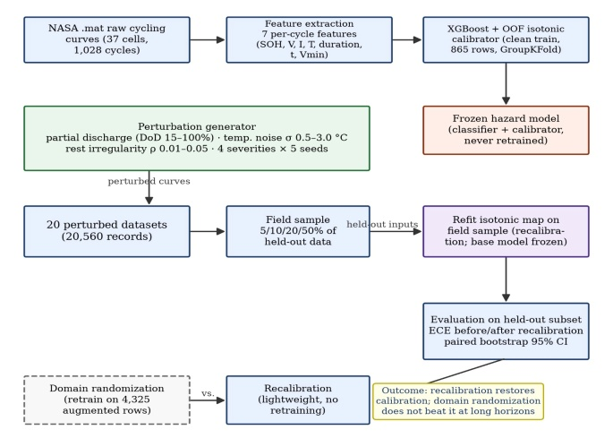
Fig. 1. Methodology: a frozen XGBoost hazard model with out-of-fold isotonic calibration is stress-tested under synthetic operational perturbations; recalibration on a field sample is compared with domain-randomized retraining

Results
- Clean baseline
On the strictly held-out test partition, the frozen model's calibration is modest even on clean data: ECE ranges from 0.231 at H = 20 to 0.413 at H = 50 (Table III). These honest baselines make the degradation analysis below conservative, not inflated. Discrimination is modest throughout (AUC ≈ 0.48–0.59), typical of autocorrelated pre-failure labels; the practical headroom is in probability magnitudes, which is exactly the axis this paper targets. Clean ECE also varies with horizon, from 0.231 at H = 20 to 0.413 at H = 50, so horizon affects calibration even without any perturbation.
TABLE III. CLEAN BASELINE ON THE HELD-OUT TEST PARTITION
H | ECE raw | ECE cal | AUC cal | Brier
H=10 | 0.375 | 0.337 | 0.578 | 0.253
H=20 | 0.336 | 0.231 | 0.594 | 0.213
H=30 | 0.380 | 0.369 | 0.593 | 0.332
H=50 | 0.492 | 0.413 | 0.485 | 0.410

Calibration degrades and saturates
Under perturbation, ECE rises at three of four horizons, from 0.231 to 0.305 at H = 20 and from 0.413 to 0.514 at H = 50, with little change at H = 10 (0.337 to 0.324; Table IV). The degradation saturates at the mildest severity: mean perturbed ECE is flat across severity levels, at 0.394, 0.382, 0.372, and 0.380 for S1 through S4 (Fig. 3). Fig. 4 explains the saturation. In full discharge Vmin reaches about 2.3 V; at the mildest truncation it jumps to about 3.2 V, a 37% shift the frozen calibrator cannot absorb. The reliability diagrams at H = 20 (Fig. 2) show the same pattern: every severity curve bends below the diagonal in the same probability region, and the curves cluster instead of spreading, confirming that saturation is a property of the shift rather than of severity. Within each severity the shift is dominated by the truncation draw rather than the noise level: mean ECE varies by at most 0.022 between S1 and S4 at any horizon, while the clean-to-perturbed gap reaches 0.101 at H = 50. Discrimination is stable by contrast: AUC moves by less than 0.1 at every horizon (0.594 → 0.609 at H = 20) and does not track the ECE collapse, so the perturbation attacks probability magnitudes, not ranking quality.
TABLE IV. CLEAN AND PERTURBED ECE ON THE HELD-OUT PARTITION (MEAN ACROSS 4 SEVERITIES × 5 SEEDS)
H | ECE clean | ECE perturbed
H=10 | 0.337 | 0.324
H=20 | 0.231 | 0.305
H=30 | 0.369 | 0.385
H=50 | 0.413 | 0.514
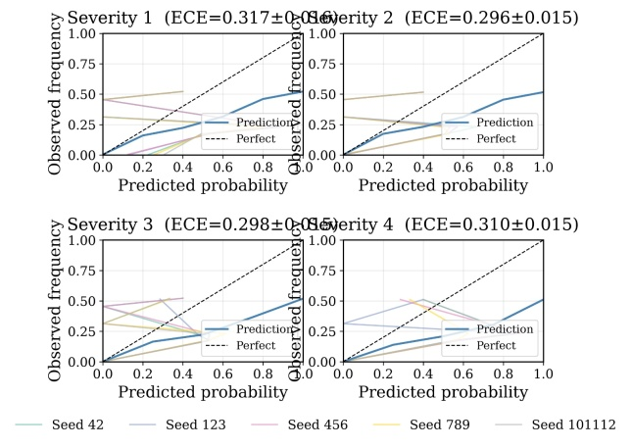
Fig. 2. Reliability diagrams at H = 20 across severities S1–S4 (five seeds each). Deviation from the diagonal saturates at the mildest perturbation.
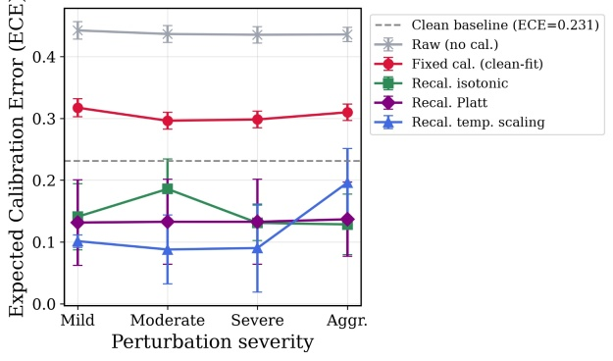
Fig. 3. ECE vs. severity level for each horizon. Degradation does not grow with severity; the mildest level already carries most of the shift.
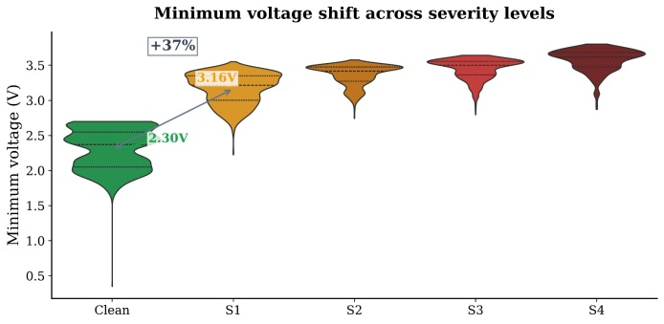
Fig. 4. Minimum-voltage distribution, clean vs. perturbed (seed 42). The mean shifts from 2.3 V to 3.2 V by severity 1, driving the calibration collapse.

Recalibration data requirement
Refitting the isotonic map on an independent field sample restores calibration, and the requirement is small. Mean held-out ECE falls monotonically with sample fraction, from 0.221 at 5% to 0.175 at 10%, 0.121 at 20%, and 0.080 at 50% (Fig. 5, Table V). The improvement saturates near a 20% fraction at every horizon. Paired bootstrap intervals for the 10% configuration exclude zero at all horizons, with gains from 0.125 [0.078, 0.168] at H = 10 to 0.389 [0.363, 0.413] at H = 50 and Cohen’s d_{z} from 1.2 to 6.7 (Table VI). For a deployment window of a few hundred cycles, a 20% sample is a modest collection effort, and it leaves the base model untouched. The curve is steep between 5% and 20% and flattens beyond: the marginal gain from 20% to 50% is only 0.041 in mean ECE, which bounds the operator's collection effort. The requirement is also approximately horizon-independent: at a 20% fraction, per-horizon means cluster between 0.098 (H = 10) and 0.149 (H = 30), within 0.05 of each other. Two checks support the sweep. Seed-to-seed spread of ECE at a 10–20% fraction is 0.06–0.08, well below the gains of Table VI, so the requirement is not an artifact of any single augmentation. The paired rank-biserial correlation between recalibrated and uncalibrated ECE is 0.88 at H = 10 and 1.0 at longer horizons, so every condition improves and no outlier drives the mean.
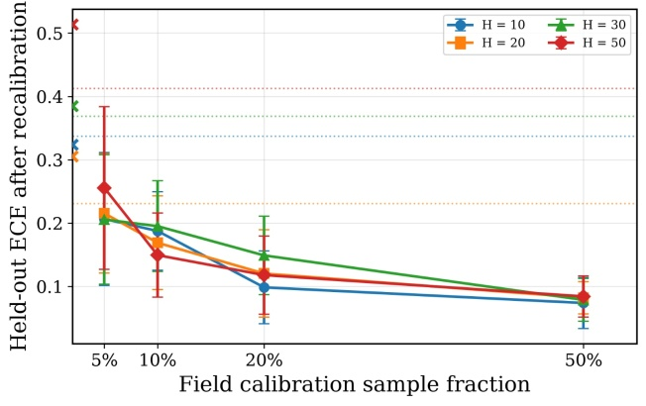
Fig. 5. Held-out ECE after recalibration vs. field sample fraction, per horizon (mean ± std across severities and seeds). Markers at 2% show perturbed ECE without recalibration; dotted lines show the clean baseline per horizon.
TABLE V. RECALIBRATED ECE VS. FIELD SAMPLE FRACTION (MEAN ACROSS 4 SEVERITIES × 5 SEEDS)
Fraction | H=10 | H=20 | H=30 | H=50 | Mean
5% | 0.206 | 0.215 | 0.206 | 0.255 | 0.221
10% | 0.187 | 0.169 | 0.195 | 0.149 | 0.175
20% | 0.098 | 0.120 | 0.149 | 0.118 | 0.121
50% | 0.074 | 0.082 | 0.079 | 0.084 | 0.080

TABLE VI. RECALIBRATION GAIN AT A 10% FIELD SAMPLE (PAIRED BOOTSTRAP, 20 PAIRS PER HORIZON)
H | ECE gain | 95% CI | Cohen’s d_{z}
H=10 | 0.125 | [0.078, 0.168] | 1.19
H=20 | 0.159 | [0.135, 0.184] | 2.77
H=30 | 0.248 | [0.218, 0.275] | 3.73
H=50 | 0.389 | [0.364, 0.414] | 6.74

Domain randomization is not competitive
Retraining the base classifier on perturbed data is the standard alternative to post-hoc recalibration. A fresh XGBoost is trained on the clean training set augmented with perturbed copies at all four severities, for a total of 4,325 rows (the 865-row clean set plus four perturbed copies). Domain randomization wins ECE only at H = 10, at 0.074 against 0.199, and loses at every longer horizon, where recalibration reaches 0.125–0.146 while domain randomization stays between 0.314 and 0.381. The added complexity of generating perturbed training data and retraining is therefore not justified. Lightweight recalibration remains the preferred deployment strategy. The gap widens with horizon: at H = 50 domain randomization reaches 0.381 against 0.146 for recalibration.

VI. Discussion
- An operational boundary map
Aggregating across conditions yields three operating zones. Direct deployment of the frozen model is unsafe under partial cycling: ECE exceeds 0.28 at most (horizon, severity) pairs. Recalibrated operation enters a warning zone (ECE 0.10–0.20) at all horizons and reaches the safe zone (ECE < 0.10) at several horizons. Recalibration is therefore not optional for field deployment; the open question is only how quickly it can be performed, and Fig. 5 shows the answer is about one-fifth of a field window. The map also doubles as a monitoring instrument: ECE can be re-estimated on each recalibration sample, so a drift back toward the warning zone flags that a refresh is due before reliability degrades.
- Deployment recipe
The results support a concrete procedure: deploy the frozen model; collect about 20% of a field window from normal operation; extract the same seven per-cycle features; fit a fresh isotonic map on the raw probabilities versus observed outcomes; redeploy with the recalibrated map; refresh the calibrator periodically as conditions drift (Fig. 6). No base retraining, no original training data, and no new features are required. The recipe assumes the shift is static within a refresh window; under continuous drift the interval must shrink, and the monitoring loop of Section VI-A flags when it should.
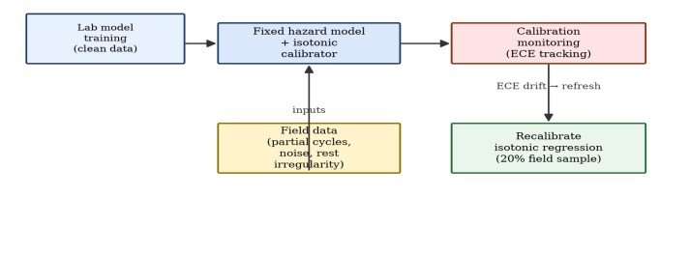
Fig. 6. Calibration-aware deployment: the frozen hazard model is paired with a lightweight recalibration step on field data.
- Limitations
Several caveats bound the conclusions. The perturbation model preserves the true SOH trajectory, isolating observational shift but not the coupled degradation dynamics of real partial cycling. Results are for a single LCO chemistry, a single model family, and a single 163-record held-out partition. Temperature noise is Gaussian and does not model thermal gradients or diurnal variation. Replication on larger multi-chemistry datasets is warranted, and the ECE-only metric could be extended with MCE or ACE. Operationally, recalibration assumes outcome labels for the field sample; in a deployed fleet these require an on-line SOH estimate, itself a model output, so the loop inherits that estimator's noise. Threshold monitoring (Section VI-A) mitigates this by triggering a refresh before drift accumulates. Within these limits, the answer to the motivating question is clear: calibration of a frozen battery hazard model degrades sharply under operational shift, and a field sample of roughly 20% of a deployment window restores it by refitting the calibrator.

VII. Conclusion
This paper quantified the cost of restoring calibration for a battery hazard model under operational distribution shift. Three findings stand out. Calibration is fragile: ECE rises from 0.23–0.41 on clean data to 0.31–0.51 under perturbation and saturates at the mildest severity. The fix is cheap: a 20% field sample suffices to refit the isotonic map at every horizon, with gains well separated from zero. And the conventional fix, domain-randomized retraining, does not beat this lightweight maintenance step at longer horizons. Operators can keep a validated base model, collect a modest field sample, and maintain trustworthy probabilities through periodic recalibration. Future work targets non-Gaussian and coupled perturbation families that move degradation dynamics as well as observations, adaptive refresh schedules triggered by stream ECE, and replication across chemistries and model families.
VIII. References
- Y. Che, X. Hu, X. Lin, J. Guo, and R. Teodorescu, “Health prognostics for lithium-ion batteries: Mechanisms, methods, and prospects,” Energy & Environmental Science, 2023.
- Y. Wang, S. Guo, Y. Cui, L. Deng, L. Zhao, J. Li, and Z. Wang, “A detailed review of machine learning-based state of health estimation for lithium-ion batteries: Data, features, algorithms, and future challenges,” Renewable and Sustainable Energy Reviews, 2025.
- J. Lu, R. Xiong, J. Tian, C. Wang, and F. Sun, “Deep learning to estimate lithium-ion battery state of health without additional degradation experiments,” Nature Communications, 2023.
- S. Jafari, J.-H. Yang, and Y.-C. Byun, “Optimized XGBoost modeling for accurate battery capacity degradation prediction,” Results in Engineering, 2024.
- B. Bairwa, K. Pareek, and V. K. Jadoun, “Cycle based state of health estimation of lithium ion cells using deep learning architectures,” Scientific Reports, 2025.
- M. Massaoudi, H. Abu-Rub, and A. Ghrayeb, “Advancing lithium-ion battery health prognostics with deep learning: A review and case study,” IEEE Open Journal of Industry Applications, 2024.
- Y. Liu, B. Hou, M. Ahmed, Z. Mao, J. Feng, and Z. Chen, “A hybrid deep learning approach for remaining useful life prediction of lithium-ion batteries based on discharging fragments,” Applied Energy, 2024.
- B. Zhao, W. Zhang, Y. Zhang, C. Zhang, C. Zhang, and J. Zhang, “Research on the remaining useful life prediction method for lithium-ion batteries by fusion of feature engineering and deep learning,” Applied Energy, 2024.
- J. Li, S. Zhao, M. S. Miah, and M. Niu, “Remaining useful life prediction of lithium-ion batteries via an EIS based deep learning approach,” Energy Reports, 2023.
- J. Chen, P. Li, and L. Wu, “Joint prediction of state of health and remaining useful life of lithium-ion batteries using single-cycle charging data,” Energy, 2025.
- S. Wang, P. Wang, L. Li, K. Li, H. Xie, and F. Jiang, “An enhanced deep learning framework for state of health and remaining useful life prediction of lithium-ion battery based on discharge fragments,” Journal of Energy Storage, 2025.
- G. Dong, N. Hua, H. Chen, and Y. Lou, “Deep transfer learning enabled state of health estimation of lithium-ion battery using voltage sample entropy under fast charging profiles,” IEEE Transactions on Transportation Electrification, 2025.
- J. C. Platt, “Probabilistic outputs for support vector machines and comparisons to regularized likelihood methods,” Tech. Rep., Microsoft Research, 1999.
- B. Zadrozny and C. Elkan, “Transforming classifier scores into accurate multiclass probability estimates,” in Proc. 8th ACM SIGKDD Int. Conf. Knowledge Discovery and Data Mining, 2002.
- A. Niculescu-Mizil and R. Caruana, “Predicting good probabilities with supervised learning,” in Proc. 22nd Int. Conf. Machine Learning (ICML), 2005.
- M. P. Naeini, G. F. Cooper, and M. Hauskrecht, “Obtaining well calibrated probabilities using Bayesian binning,” in Proc. 29th AAAI Conf. Artificial Intelligence, 2015.
- C. Guo, G. Pleiss, Y. Sun, and K. Q. Weinberger, “On calibration of modern neural networks,” in Proc. 34th Int. Conf. Machine Learning (ICML), 2017.
- Y. Ovadia, E. Fertig, J. Ren, Z. Nado, D. Sculley, S. Nowozin, J. Dillon, B. Lakshminarayanan, and J. Snoek, “Can you trust your model’s uncertainty? Evaluating predictive uncertainty under dataset shift,” in Proc. 33rd Conf. Neural Information Processing Systems (NeurIPS), 2019.
- D. Levi, L. Gispan, N. Giladi, and E. Fetaya, “Evaluating and calibrating uncertainty prediction in regression tasks,” Sensors, 2022.
- J. Gawlikowski, C. R. N. Tassi, M. Ali, et al., “A survey of uncertainty in deep neural networks,” Artificial Intelligence Review, 2023.
- A. N. Angelopoulos and S. Bates, “Conformal prediction: A gentle introduction,” Foundations and Trends in Machine Learning, 2023.
- M.-L. Zhang and D.-B. Wang, “Uncertainty calibration in deep learning: Methods, emerging challenges, and LLM frontiers,” Journal of Computer Science and Technology, 2026.
- I. Gibbs and E. J. Candès, “Conformal inference for online prediction with arbitrary distribution shifts,” Journal of Machine Learning Research, 2024.
- J. Wu, “Distribution shifts in trustworthy machine learning,” AI Magazine, 2026.
- L. Güitta-López, J. Boal, and A. J. López-López, “Sim-to-real transfer via a style-identified cycle consistent generative adversarial network: Zero-shot deployment on robotic manipulators through visual domain adaptation,” Engineering Applications of Artificial Intelligence, 2025.
- P. M. Scheikl, E. Tagliabue, B. Gyenes, M. Wagner, D. Dall’Alba, P. Fiorini, and F. Mathis-Ullrich, “Sim-to-real transfer for visual reinforcement learning of deformable object manipulation for robot-assisted surgery,” IEEE Robotics and Automation Letters, 2022.
- B. Saha and K. Goebel, “Battery data set, NASA Ames Prognostics Data Repository,” NASA Ames Research Center, 2007.
- J. Wang, P. Liu, J. Hicks-Garner, E. Sherman, S. Soukiazian, M. Verbrugge, H. Tataria, J. Musser, and P. Finamore, “Cycle-life model for graphite-LiFePO4 cells,” Journal of Power Sources, vol. 196, no. 8, pp. 3942–3948, 2011.
- T. Chen and C. Guestrin, “XGBoost: A scalable tree boosting system,” in Proc. 22nd ACM SIGKDD Int. Conf. Knowledge Discovery and Data Mining, 2016.

